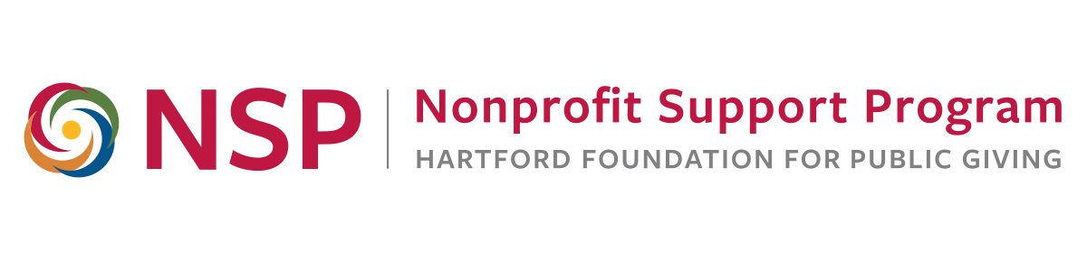
NSP Evaluation Roundtable

Goals:
- Promote ongoing nonprofit discussion, sharing and learning about evaluation
- Provide new and relevant information to meet nonprofit evaluation needs
- Provide a community of practice for area nonprofit and evaluation professionals

Today:
Nonprofit Evaluation Basics
8:30 to 12:00 a.m., Thursday, October 11,2018

Agenda

8:00 – 8:30 Refreshments and Networking

8:30 – 9:20 Introductions and Evaluation Overview

9:20 – 10:05 Collecting and Analyzing Evaluation Data, Part 1

10:05 – 10:15 Break and Networking

10:15 – 11:35 Collecting and Analyzing Evaluation Data, Part 2

11:35 – 11:45 Evaluation Reporting, Final Advice

11:50 – 12:00 Closure

About today’s speaker

Anita Baker, Ed.D., Evaluation Services. Anita has worked as an evaluator for over 25 years and is an independent consultant providing a variety of evaluation-related services to research and evaluation organizations, universities, foundations, and non-profit agencies that provide services to youth and families. Since 2006, she has worked closely with the Hartford Foundation for Public Giving providing training to many local area nonprofit organizations. Anita has designed a comprehensive set of evaluation training materials and evaluative thinking assessment tools, which are available, free of charge on her website. She earned her Doctorate in Education from Columbia University, Teacher’s College in 1991, and served as a project director and senior program officer of the Academy for Educational Development in New York City and as a project director at the OMG Center for Collaborative Learning in Philadelphia.

Learn more at: www.evaluationservices.co
Contact: anitabaker@evaluationservices.co

