**Hello HFPG Nonprofit Support Program Participants!**

This packet is intended to provide you with various Evaluative Thinking templates for use in your organizations. These templates and strategies were reviewed during the *Evaluative Thinking 101: Putting Evaluative Thinking Into Practice* training in March 2025.

--

*Now, let’s jump in!*

As a reminder, **evaluative thinking** is the ability to use evaluation skills to inform learning and decision-making as a matter of habit within an organization. It is a disciplined approach to inquiry and reflective practice, where practitioners ask thoughtful questions about what you do and why you do it to improve effectiveness.

Evaluative thinking is used to inform programs, strategies, initiatives as well as human resources, marketing, finance, fundraising, board management, partnerships, etc. It is a cultural shift within an organization, and a mechanism to make sound judgements backed by solid evidence.

**What if my organization isn’t ready for evaluative thinking?**

Chances are, your organization is already engaging in evaluative thinking practices. Conducting feedback surveys, engaging in group discussion after an event, utilizing market research to inform organizational strategy are all elements of evaluative thinking. The goal could be to build on these practices incrementally, and over time, to gradually shift your organization to embed these elements consistently and regularly to become part of your culture and habits.

1. ***Impact/Effort Matrix***

What it is: A tool that provides clarity in determining easy solutions that produce the most effect (i.e., high ROI).

What to do: Decide on a project or area of focus. Then, list potential actions/solutions. Next, plot them on the matrix according to their impact and the effort required. Focus on "Quick Wins" (high impact, low effort) first. Finally, prioritize actions based on this analysis.

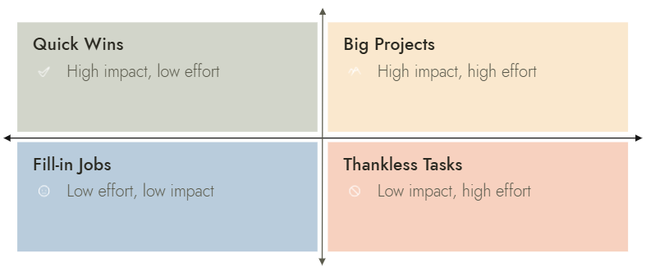

1. ***MoSCoW Method***

What it is: An analysis technique used to prioritize and manage requirements of a project or initiative.

What to do: After your team is aligned on which project or initiative to focus on, categorize requirements or features into the following 4 categories below (based on the info you have at this time). Then develop insights and actions based on this analysis.

**Must Have:** Non-negotiables within a project that are deemed mandatory by the team; essential for success

**Should Have:** Important elements that are not vital but add significant value

**Could Have:** Nice to have elements that will have a small impact if left out

**Won’t Have:** Elements that are not priority for this specific project or time frame

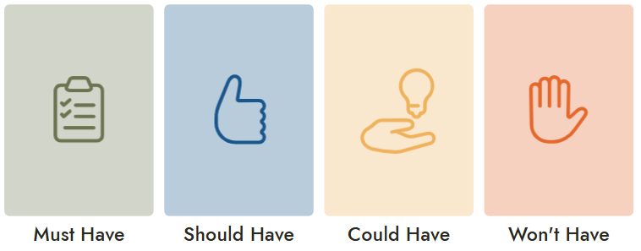

|  |  |  |  |
| --- | --- | --- | --- |
|  |  |  |  |

1. ***After Action Review***

What it is: A process used to analyze a completed event or project to identify successes and future growth opportunities.

The process is an active discussion based on the questions below. For this method to be most effective, transparency and candor will provide space for team members to challenge current ways of thinking and performing.

What to do: After a completed project or initiative, meet with the team members involved, and spend time discussing each question - in the order below. Take notes on each response, and plan next steps based on the discussion’s outcome.

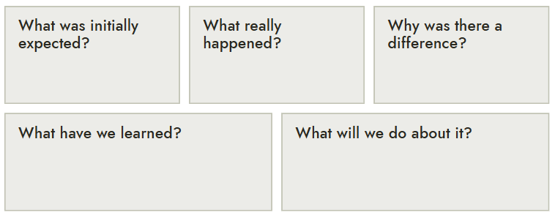

1. ***“5 Whys” Root Cause Analysis***

What it is: A method to uncover the true root cause of an issue by asking "why" five times. It is designed to drill down to the details of a problem or solution by peeling away the layers of “symptoms”.

What to do: With your team, clearly identify a problem or solution to be explored. Write it down. Then ask “why” five times, and write the answers to each until you identify the root cause or solution. Finally, brainstorm potential solutions based on the root cause.

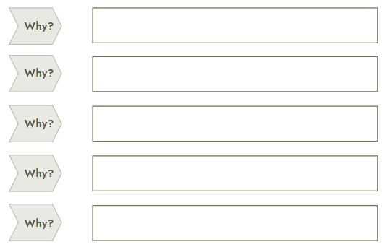

1. ***Alternative Explanations Exercise (Devil’s Advocate)***

What it is: An exercise where someone assumes a contrary or opposing viewpoint to test the strength of an argument, idea, or decision. This encourages critical thinking, exposes potential flaws, and prevents groupthink.

What to do: Identify someone on the team to play the role of “devil’s advocate.” During group discussion, they should focus on an idea being presented and stick to the soundness and merits of the arguments being made by providing data, logic, or experience. The team member should also offer new and alternative options to explore.

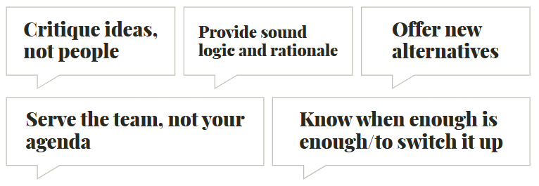

The group should respond to each of the five items below to organize its thinking.

1. **Original idea or proposal:**
2. **Alternative perspective/explanation:**
3. **Potential flaws or weaknesses in the original idea:**
4. **New alternatives that address these concerns:**
5. **How this exercise improved the original concept:**
6. ***Force Field Analysis***

What it is: A decision-making and problem-solving tool to help understand the dynamics of change by identifying and analyzing the "driving forces" that promote change and the "restraining forces" that hinder it.

What to do:

1. **State and describe the proposal for change:** Describe the proposed change, its elements, and objectives.
2. **Identify driving forces:** With your team, list as many factors as possible in favor of implementing the proposed change, and place those factors on the left part of the diagram.
3. **Identify restraining forces:** With your team, list as many factors as possible opposing the implementation of the proposed change, and place those factors on the right part of the diagram.
4. **Incorporate scores:** Evaluate the impact of the identified factors in this step by assigning a score to each one on a scale of 1-5 (5 being the strongest). As scoring is subjective, incorporate your team’s perspective on how each factor will be scored.
5. **Tally and analyze:** Tally each side to see which weighs more (has the highest score when added). For a change to be implemented, the *driving forces* should be stronger than the *restraining forces*.

**Based on this analysis, the change is:** *(select one)*

* Likely to succeed (driving forces significantly outweigh restraining forces)
* Potentially viable with targeted interventions (forces relatively balanced)
* Likely to face significant resistance (restraining forces outweigh driving forces)

