

|  |  |
| --- | --- |
|  | **MASTERING THE ART OF CRITICAL CONVERSATIONS:** WORKBOOK |
|  |  |

**Play to win:**

**How to set up both parties for success.**

**1 Get clear on the conversation:**



* What’s the conversation, and with whom? What’s at stake?
* What is your intention/purpose for this conversation?
* What happens if nothing changes?

**2 Provide time to prepare:**

What do you need to prepare, what does the other need to prepare?

**3 Set a winning environment and define success:**

What kind of environment favors success? (formal, informal, walking, etc.)

**4 Be aware of your listening and listeners:**

What of your listeners might show up, you need to be aware of?

**5 Be prepared to pause and regroup:**

If a break is needed, how do we intend to regroup and when?

**6 Wrap-up with what’s clear, not clear, needed, next:**

Ask, what are you leaving this conversation with?

**7 Follow-up:**

How and when?

|  |  |
| --- | --- |
| **1** | **BREAK FREE. CREATE POSSIBILITY. LEAD DIFFERENTLY. VISIT** [**WWW.BE-GENERATIVE.COM**](http://WWW.BE-GENERATIVE.COM) |

|  |  |
| --- | --- |
|  | **GENERATIVE LISTENING WORKSHEET** |

**Listening is a way to create space.**

In that space, ideas, futures, even people can come into existence.

**Listening is the foundation in which conversations exist:**Quality of listening = Quality of conversation = Quality of our experience



**Questions are Doorways** opening new rooms of listening and conversation

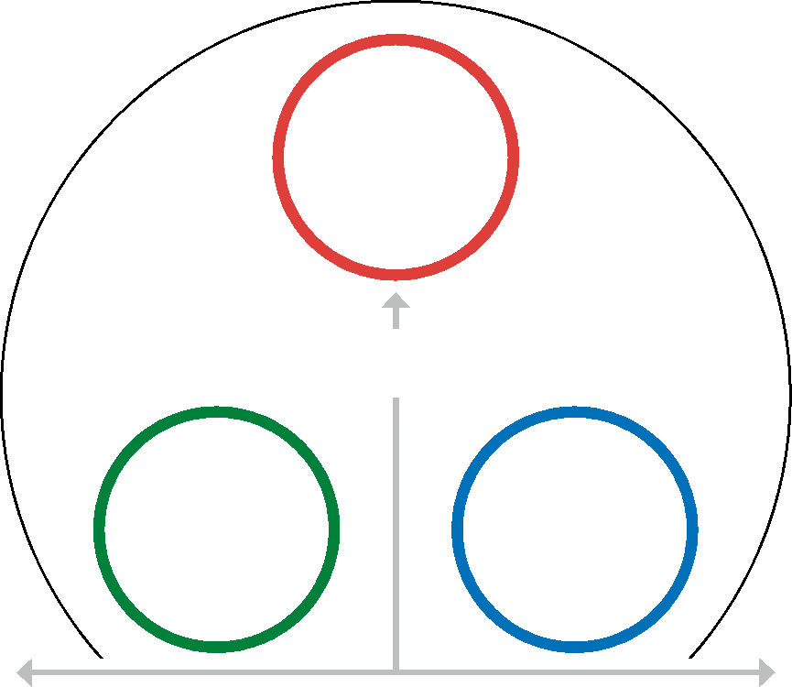

**Listening is a sacred act:**

Ichigo Ichie (one moment = one lifetime)

**AUTOMATIC LISTENING**

|  |  |
| --- | --- |
| **2** | **BREAK FREE. CREATE POSSIBILITY. LEAD DIFFERENTLY. VISIT** [**WWW.BE-GENERATIVE.COM**](http://WWW.BE-GENERATIVE.COM) |

|  |  |
| --- | --- |
|  | **GENERATIVE LISTENING WORKSHEET** |

**We often listen automatically for what is and what has been. This can unintentionally trap us in conversations focused on problems and fixes, limiting our ability to explore new possibilities. To break free and step into uncharted territory, we need to intentionally expand our listening. This creates a powerful space between our current reality and the exciting future we want.**



|  |  |
| --- | --- |
| **PROVIDES FRAMEWORK FOR STRATEGIC ACTION** | |
| **1.** | **6.** |
| **2.** | **7.** |
| **3.** | **8.** |
| **4.** | **9.** |
| **5.** | **10.** |
|  |  |



**PROVIDES CONTEXT TO EXAMINE**

**WHAT’S NOT WORKING**

|  |  |
| --- | --- |
| **3** | **BREAK FREE. CREATE POSSIBILITY. LEAD DIFFERENTLY. VISIT** [**WWW.BE-GENERATIVE.COM**](http://WWW.BE-GENERATIVE.COM) |



|  |  |
| --- | --- |
|  | **MASTERING THE ART OF CRITICAL CONVERSATIONS:** WORKBOOK |
|  |  |

**Major Concepts**

**3 You get what you allow. You get what you demonstrate.**



**What are critical conversations?**

**1**

**Critical Conversations are when... Critical Conversations are not...**

* a demand,warning or reprimand
* an ultimatum
* a directive or announcement
* one-way
* something is at stake
* there’s impact if nothing changes
* action is required by both parties
* it is a conversation

**We all have a cast of characters that listen for us. Who are yours?**

**2**

**Encourage Discourage**

* the fixer
* the faker
* the responder
* the storyteller
* the hijacker
* the intentional
* the responsible
* the understanding
* the curious
* the investor

Your team pays attention to everything you do, everything you say, and everything you are.

**4 In the absence of understanding, we assume the worst.**

Resist the urge to generate a story that fills in the gaps of what is not understood.

**5 Clarity is kind.**

Ensure the implicit or assumed, is obvious and explicit to the other.

**6 Everyone’s behavior is designed to how your organization occurs.** If you want to change your team’s behavior, change the experience others are having.

**7 Gossip & Hearsay.**

Any conversation about someone who isn’t present is gossip.

**8 Practice over Perfection.**

The best experiences are often when you mess up, catch yourself, and recover well.

|  |  |
| --- | --- |
| **4** | **BREAK FREE. CREATE POSSIBILITY. LEAD DIFFERENTLY. VISIT** [**WWW.BE-GENERATIVE.COM**](http://WWW.BE-GENERATIVE.COM) |

|  |  |
| --- | --- |
|  | **MASTERING THE ART OF CRITICAL CONVERSATIONS: WORKBOOK** |
|  |  |

**Advanced Concepts**



**WHY DOES THIS
  
MATTER TO YOU, US,
  
THE ORGANIZATION?**

**Context**

**WHAT IS THE
  
SUBJECT MATTER,
  
ISSUE, TOPIC?**

**Content**

**WHAT NEEDS TO
  
HAPPEN WITH
  
THE CONTENT?**

**Process**

|  |  |
| --- | --- |
| **5** | **BREAK FREE. CREATE POSSIBILITY. LEAD DIFFERENTLY. VISIT** [**WWW.BE-GENERATIVE.COM**](http://WWW.BE-GENERATIVE.COM) |

|  |  |
| --- | --- |
|  | **GENERATIVE LISTENING WORKSHEET** |

**The Depths of Listening**



**+3**



**+2**

**+1**

**0**

**-2**

**-1**

**-3**



**What if you could listen someone or something into existence?**

**What if listening could call someone higher?**

**Where am I standing when I listen?**

**Generative Listening** is a practice that energizes people and possibilities. To practice, start by becoming aware of the type of listening present in the conversation. Use this guide to notice and even name the listening of both yourself and the other person. Encourage the conversation to shift towards more generative territory. This often requires you to let go of your own limited listening.

**LESS GENERATIVE MORE GENERATIVE**



This is one of several ground-breaking programs available to your team. **To learn more, visit** [**www.be-generative.com**](http://www.be-generative.com) **or scan the QR code:**

**THEIR EXISTENCE:**

You hear this persons’ identity–who they be and why they exist. You sense a deeper awareness of what they stand for, believe in, and are committed to. You feel their inner beauty.

**WHAT’S EMERGING:**

You are insatiably curious about what the other sees, is attempting to create, and is drawing out of you. You both end up surprised and delighted by what the exchange established, created or provoked.

**THEIR INTENTION:**

You sense what is behind the words they are saying, their motivation, ambition, concern. You find yourself able to more generously explore what they are offering or inviting.

**THE WORDS:**

You are listening, but only to the words, leaving the true meaning behind them unexplored. You feel more indifference, something was said, but nothing much has changed or been accomplished.

**FOR FIT:**

You are listening only for what agrees with your world view and experience. This limited listening can only lead to an agree or disagree binary, and significantly limits the inclusion of alternate perspectives so often needed to find relevant resolution.

**YOUR STORY OF THEM:**

You limit your listening to who the person, or situation has been for you in the past. “There they/we go again” is often muttered as you foreclose on the possibility this person or situation has changed and is more than your limited story.

**YOUR AGENDA:**

You wait impatiently for the other to finish so you can exit the conversation without giving the impression that you didn’t hear them. And you didn’t hear them, only you and your agenda. Worse is when you ask, “how are you” then don’t stick around for the answer.

|  |  |
| --- | --- |
| 6 | **BREAK FREE. CREATE POSSIBILITY. LEAD DIFFERENTLY. VISIT** [**WWW.BE-GENERATIVE.COM**](http://WWW.BE-GENERATIVE.COM) |